|  |  |
| --- | --- |
| **Exp No: 5**  **Date: 5.4.25** | **HTTP PST AND GET** |

**AIM:**

To write a servlet to demonstrate the difference between HTTP GET and POST methods by creating a form and hadling requests accordingly

**PROGRAM:**

**Login.java :**

**package com.rohit.servlet;  
  
import java.io.IOException;  
import java.io.PrintWriter;  
  
import javax.servlet.ServletException;  
import javax.servlet.annotation.WebServlet;  
import javax.servlet.http.HttpServlet;  
import javax.servlet.http.HttpServletRequest;  
import javax.servlet.http.HttpServletResponse;  
  
/**  
 * Servlet implementation class SignupDetails  
 */  
@WebServlet("/signup")  
public class signup extends HttpServlet {  
private static final long serialVersionUID = 1L;  
         
    /**  
     * @see HttpServlet#HttpServlet()  
     */  
    public signup() {  
        super();  
        // TODO Auto-generated constructor stub  
    }  
  
/**  
* @see HttpServlet#doGet(HttpServletRequest request, HttpServletResponse response)  
*/  
protected void doGet(HttpServletRequest request, HttpServletResponse response) throws ServletException, IOException {  
// TODO Auto-generated method stub  
response.getWriter().append("Served at: ").append(request.getContextPath());  
}  
  
/**  
* @see HttpServlet#doPost(HttpServletRequest request, HttpServletResponse response)  
*/  
protected void doPost(HttpServletRequest request, HttpServletResponse response) throws ServletException, IOException {  
String f_name=request.getParameter("fname");  
String l_name=request.getParameter("lname");  
String DOB=request.getParameter("dob");  
String gen=request.getParameter("gender");  
String add=request.getParameter("address");  
  
PrintWriter p = response.getWriter();  
  
p.println("First Name: "+f_name+"<br>");  
p.println("Last Name: "+l_name+"<br>");  
p.print("Age: "+DOB+"<br>");  
p.print("Gender: "+gen+"<br>");  
p.print("Address: "+add+"<br>");  
}  
  
}**

**SignupDetails.jsp :**

<!DOCTYPE html>  
<html>  
<head>  
<meta charset="ISO-8859-1">  
<title>Insert title here</title>  
</head>  
<body>  
  
<h1 style="color:blue">SIGNUP FORM</h1>  
<form method="post" action="/signup">  
    <label for="fname">First Name:</label>  
   
<input type="text" id="fname" name="fname" placeholder="Enter your first name" required><br><br>  
           
<label for="lname">Last Name:</label>  
   
<input type="text" id="lname" name="lname" placeholder="Enter your last name" required><br><br>  
  
<label for="dob">Date of Birth:</label>  
  
<input type="date" id="dob" name="dob" required><br><br>  
<p>  
  
<label for="gender">Gender:   </label>  
  
<label for="male">Male </label>  
  
<input type="radio" id="male" name="gender" value="Male">  
  
<label for="female">Female </label>  
  
<input type="radio" id="male" name="gender" value="Female"><br><br>  
</p>  
  
<label for="address">Address</label>  
  
<textarea type="text" name="address"></textarea><br><br>  
   
<input type="submit" value="SignUp">  
</form>  
  
</body>  
</html>

**OUTPUT:**

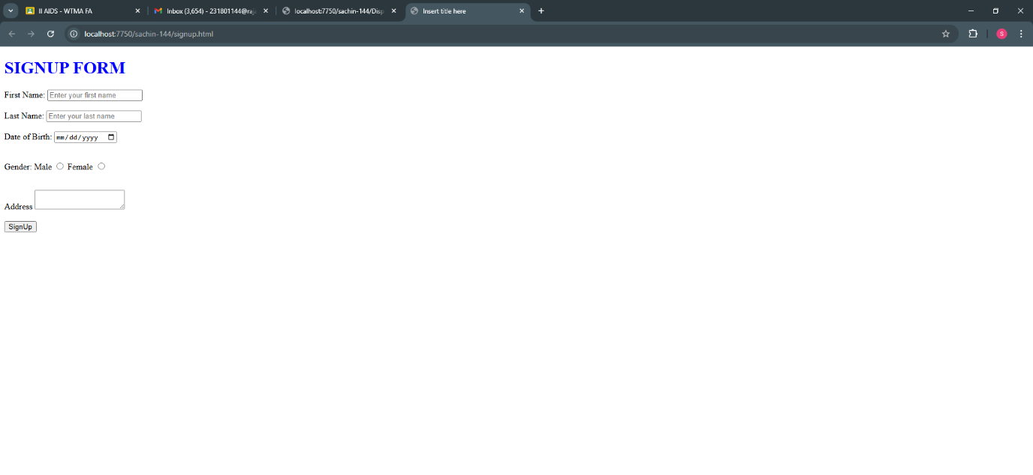

**RESULT :**Thus the experiment to write a servlet to demonstrate the difference between HTTP GET and POST methods by creating a form and hadling requests accordingly has been implemented and verified successfully